

**BINUS UNIVERSITY**

**BINUS INTERNATIONAL**

**Assignment Cover Letter**

**(Group Work****)**

|  |  |  |  |  |  |  |  |  |
| --- | --- | --- | --- | --- | --- | --- | --- | --- |
|  | | | | |  | |  | |
| **Student Information**: **Surname** | | | | | **Given Names**  **Arden**  **Edgar**  **Muhammad** | | **Student ID Number**  **2101704376**    **2101699666**  **2101704602** | |
| 1.    2.    3. | | **Arden Djaja**  **Edgar Tandiawan**  **Steven Lee** |  | |
|  |  |
| **Course Code** | **: COMP6048** |  |  | | **Course Name** | | **: Data Structure** | |
| **Class** | **: L2BC - LEC** |  |  | | **Name of Lecturer(s)** | | **:** 1. Raymondus Raymond Kosala | |
|  |  |  |  | |  | |  | |
| **Major** | **: CS** |  |  | |  | |  | |
| **Title of Assignment**  (if any) | : BINUSMON Battlegrounds | |  |  | |  | |  | |
| **Type of Assignment**    **Submission Pattern** | **:Final Project** |  |  | |  | |  | |
| **Due Date** | **: 4-05-2018** |  |  | | **Submission Date** | | **: 5-05-2018** | |

The assignment should meet the below requirements.

1. Assignment (hard copy) is required to be submitted on clean paper, and (soft copy) as per lecturer’s instructions.
2. Soft copy assignment also requires the signed (hardcopy) submission of this form, which automatically validates the softcopy submission.
3. The above information is complete and legible.
4. Compiled pages are firmly stapled.
5. Assignment has been copied (soft copy and hard copy) for each student ahead of the submission.

# Plagiarism/Cheating

BiNus International seriously regards all forms of plagiarism, cheating and collusion as academic offenses which may result in severe penalties, including loss/drop of marks, course/class discontinuity and other possible penalties executed by the university. Please refer to the related course syllabus for further information.

# Declaration of Originality

By signing this assignment, I understand, accept and consent to BiNus International terms and policy on plagiarism. Herewith I declare that the work contained in this assignment is my own work and has not been submitted for the use of assessment in another course or class, except where this has been notified and accepted in advance.

Signature of Student:

(Name of Student)

Arden Djaja, Edgar Tandiawan, Steven Lee

**Why we choose this game?**

The application that we made is for fun and enjoyable purpose because we wat to have fun while doing it as well as improving our creativity and our skill to make an application. We too want to make an RPG because we thought we can improve our skill using this subject. As result we indeed have fun while doing this and we glad we can finish it on time.

**Overview of Data Structure Implementation**

In this program we are using a simple if and else if code and the player can choose their ow adventure from the three available option that was given and when they encountered enemy, the level of the enemy is randomized so you can encountered various level of enemies and the last there will be boss appeared and the result of the battle ill change the ending

**How the program works**

The game start with the question of the player name and that want to play and the command line to bring out the text and to store it in the variable is shown in the picture below and was given a monster name “Gigasupermon” then the adventure begin

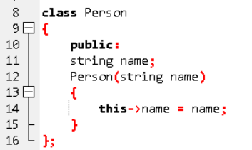

*Figure 1: Person name*

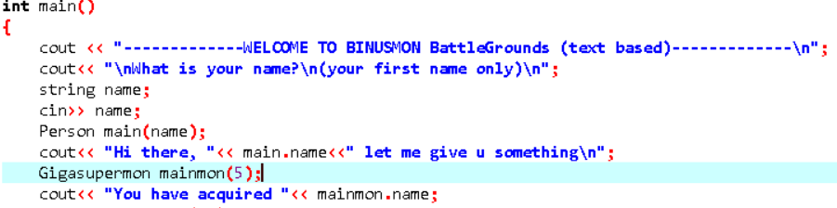

*Figure 2: Opening game screen*

In this part, it is explained u have two choices either you look around which going to lead to the end of the story of go outside to start your adventure which you can choose between three given map

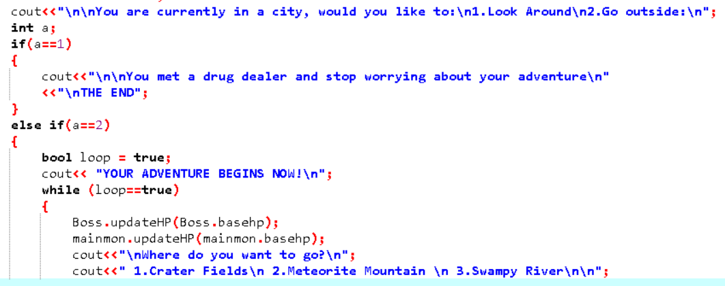

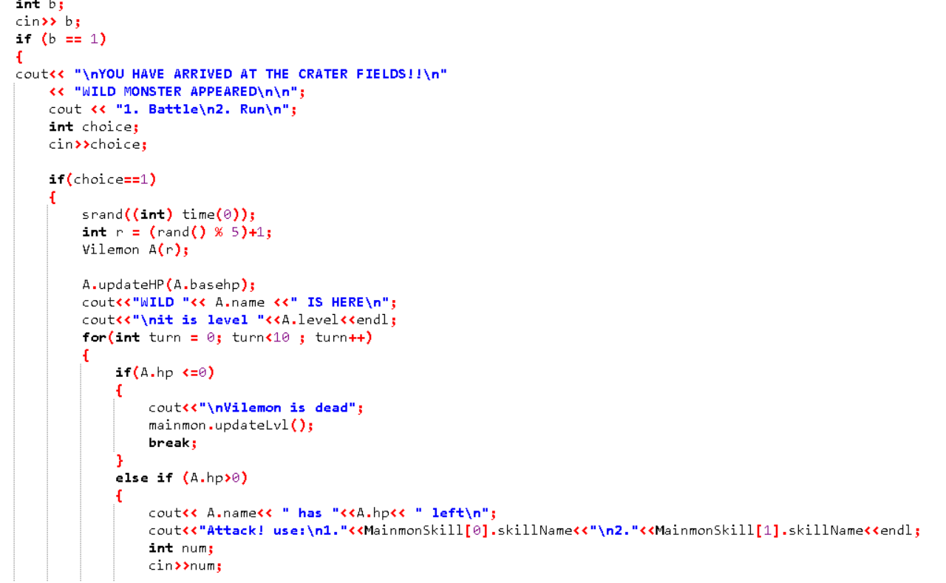*Figure 3: Choice to adventure*

*Figure 4: The Map site*

The picture above is the example if you are picking to go to the river, an then the player will encounter the enemy called “Vilemon” that have random level between the ratio of one until five

This is the fighting scene where you can pick the skill that you want to use and the damage that your monster skill will be shown and reducing the opponent health every turn with the opponent giving attack too and the opponent can use skill but random from the picture below using array function shown in figure 6

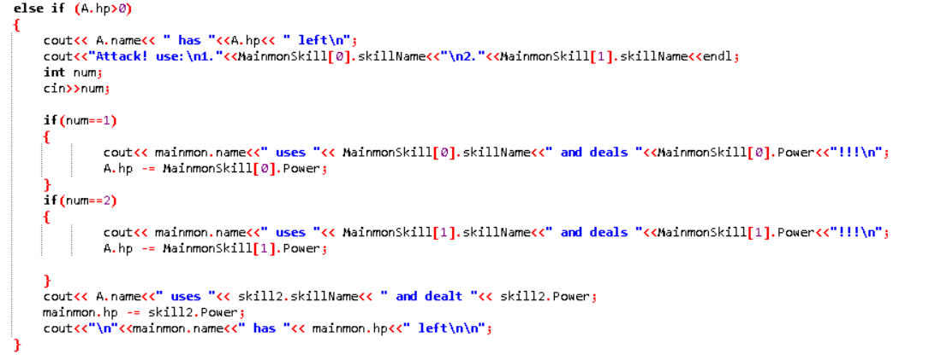

*Figure 5: The battle code*

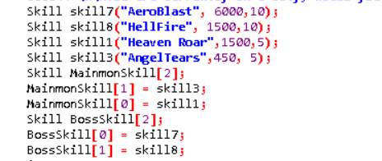

*Figure 6: Enemy skill stores in array*

This is the code that was use if you pick to go to the mountain and encounter Severnymon and the code is pretty much as in the area fields and the river also the attacking program too.

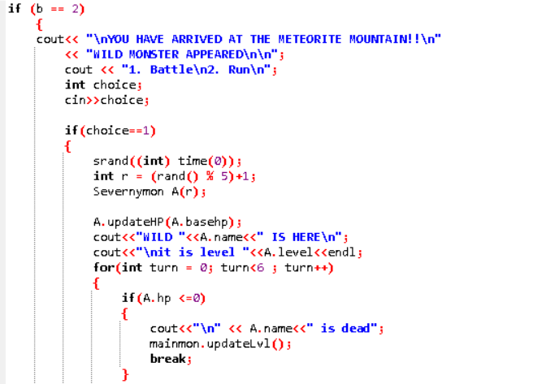

*Figure 7: Mountain Site*

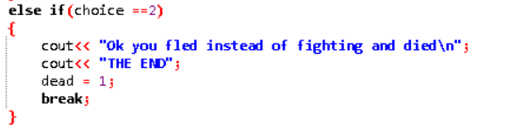 *Figure 7: Run option*

In figure 7, you can choose between the option battle or run but in this game if you run, eventually you’re going to be killed and the game ends.

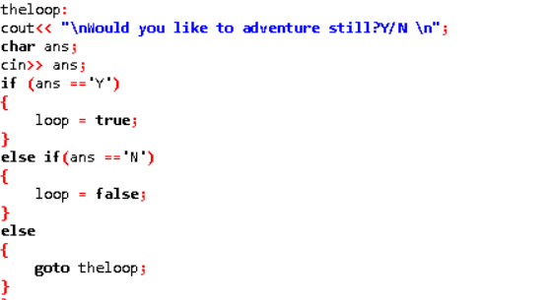

*Figure 8: The loop*

In figure 8, you can always choose the option wander around those three map to experience all of them as well to level up your monster

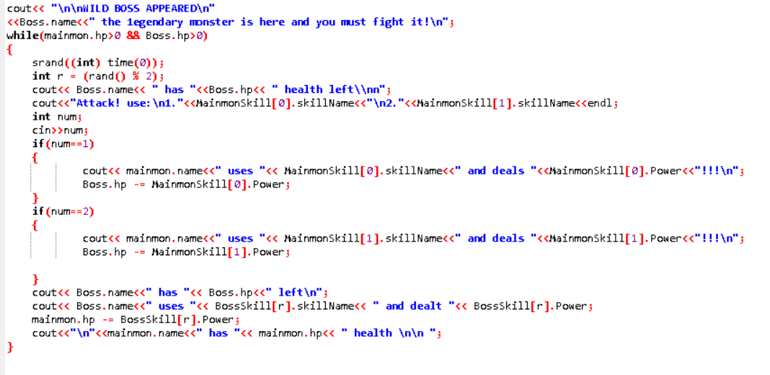

*Figure 8: The Boss*

You can always fight the boss in condition you don’t want to adventure again and in figure 9, you can have two endings which is either you win when you fight the boss or you lose but the game still end after one of the have occurred.

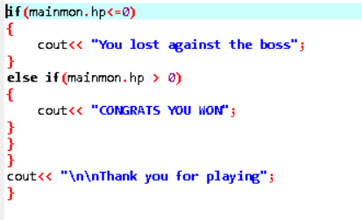

*Figure 9: The Ending*

**Program manual and results**

This game have three main map to play with and that is mountain, river, and field. You can try to go all of them until you get tired and lastly fight the boss. In that part, you can defeat the boss or get defeated depending by how you play the battle. This game use real time leveling and stats that improving every time you leveled up.

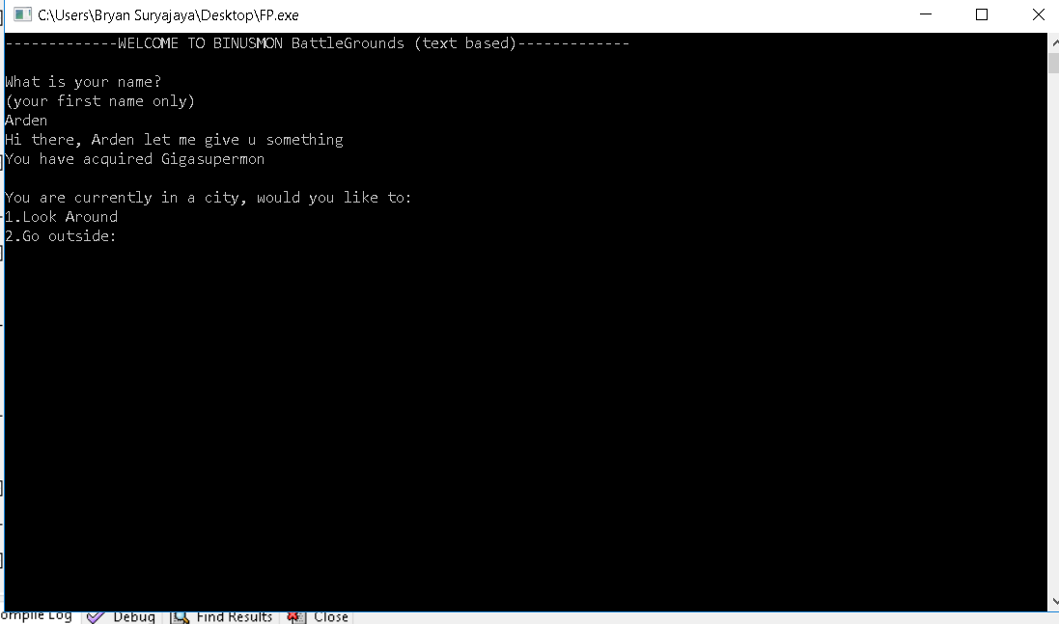Menuscreen

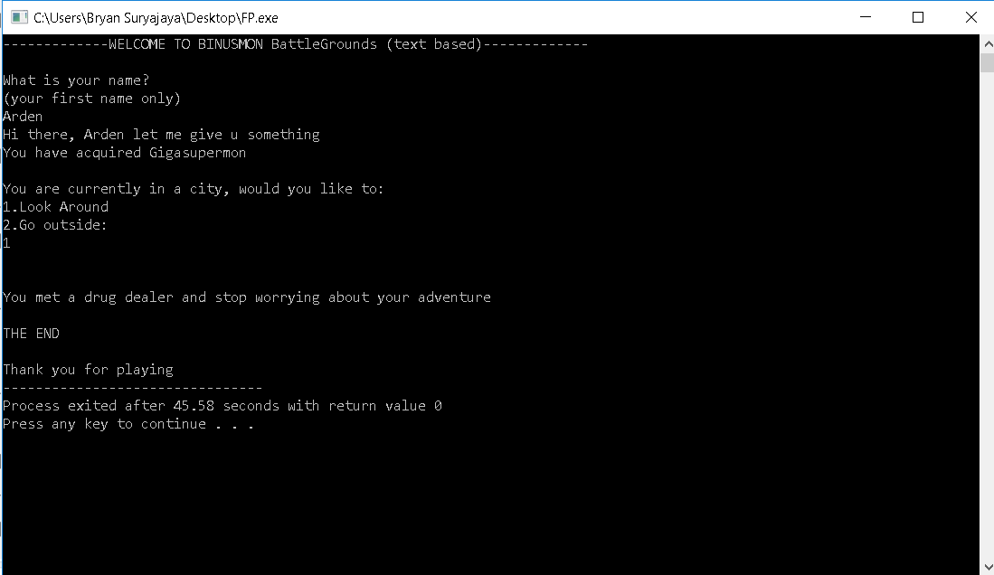Option 1

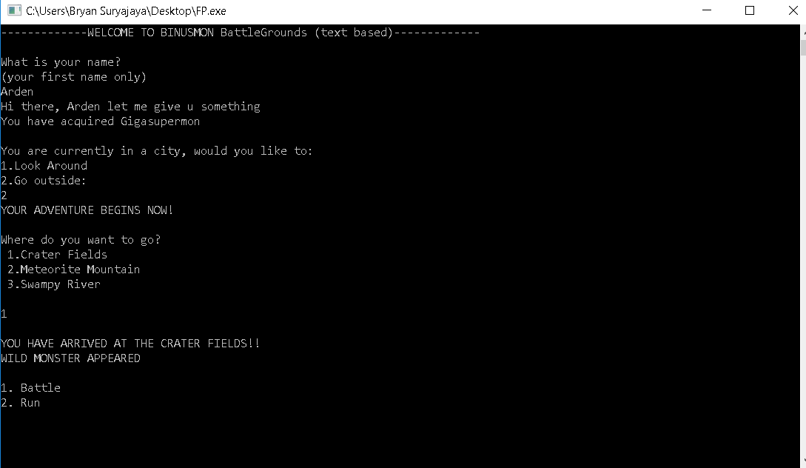Option 2

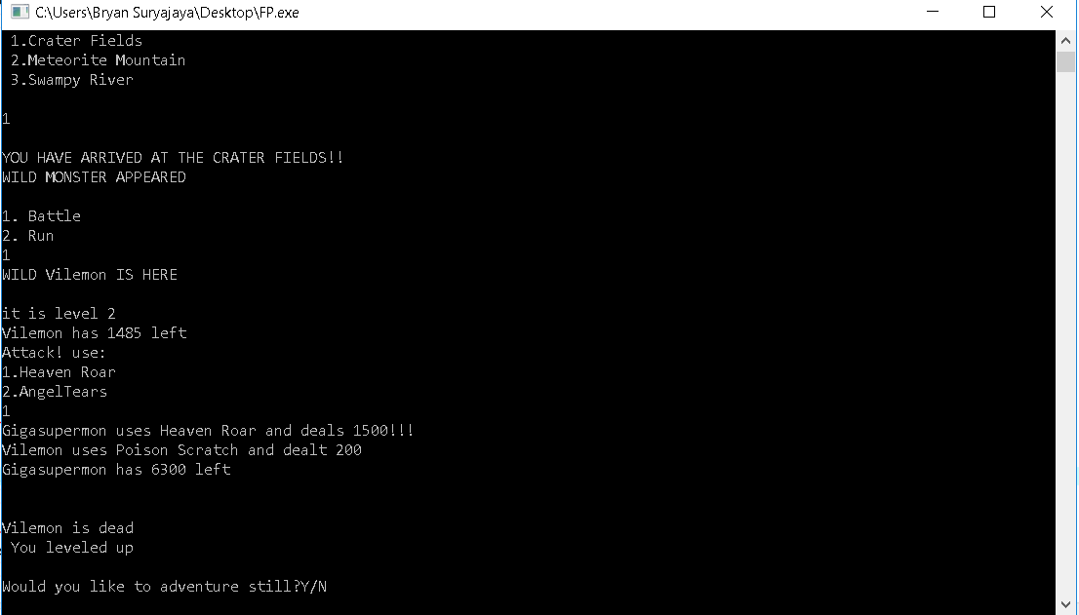Battle Scene

The option run

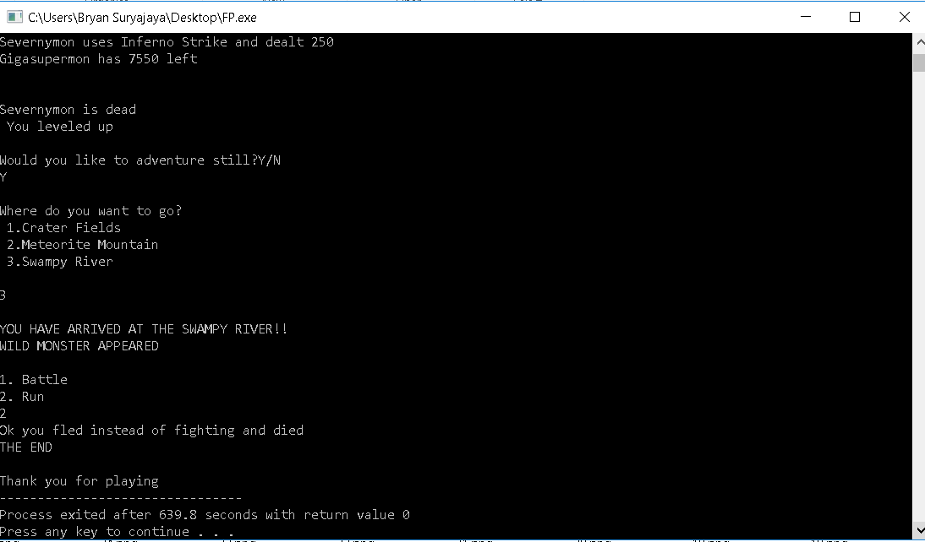

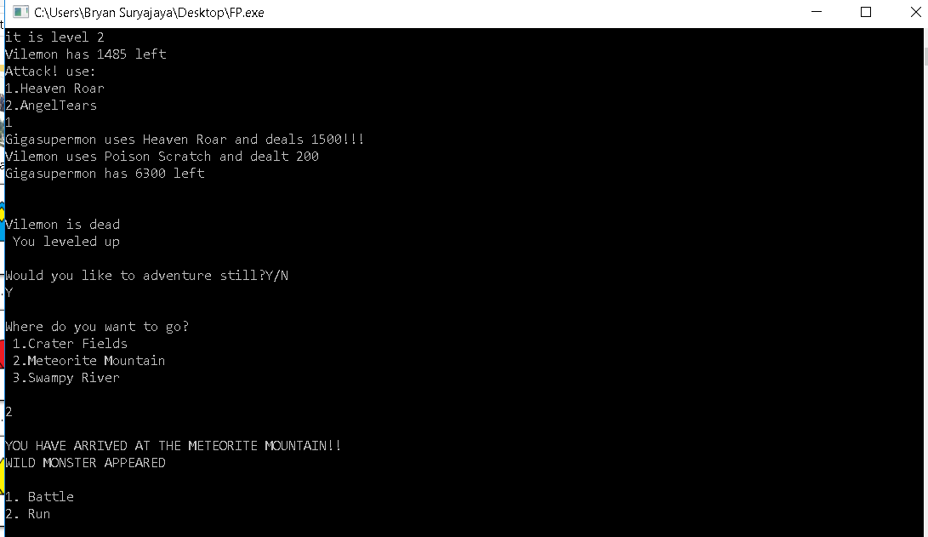` *The loop*

*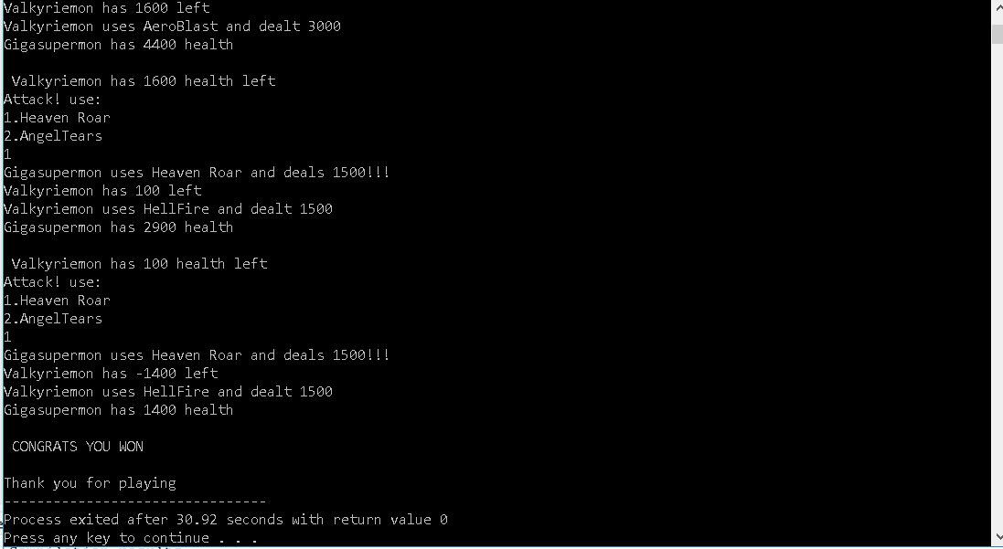Boss Battle :Won*

*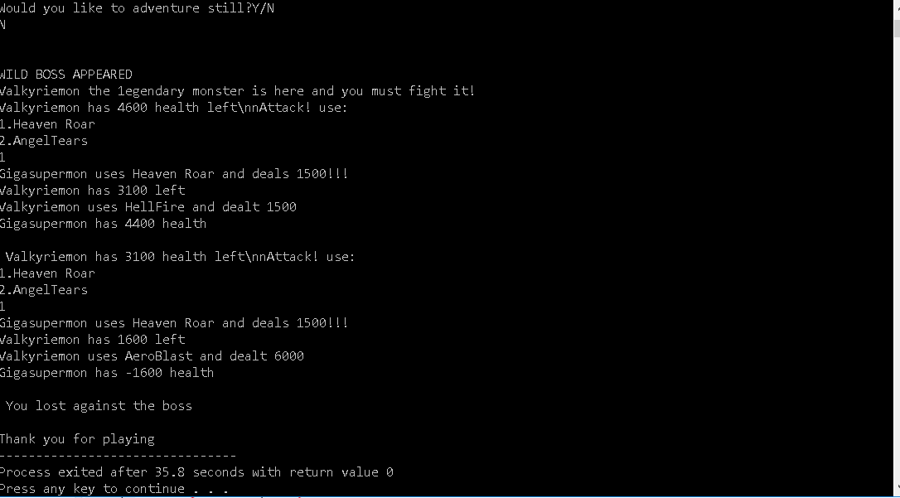Boss Battle : Lost*

Github Link :